Experiment:26 Date:18/08/2027

MONKEY BANANA PROBLEM

Aim
To write a Prolog program to implement the Monkey Banana problem.

Algorithm
- Start with the monkey on the floor.
- Check whether the box is available.
- Move the box below the banana.
- Make the monkey climb onto the box.
- Allow the monkey to reach and obtain the banana.

PROGRAM:

monkey_on_floor.
box_available.
monkey_moves_box.
monkey_climbs_box.
monkey_reaches_banana.

can_get_banana :-
monkey_on_floor,
box_available,
monkey_moves_box,
monkey_climbs_box,
monkey_reaches_banana,
write('Monkey gets the banana.').

OUTPUT:
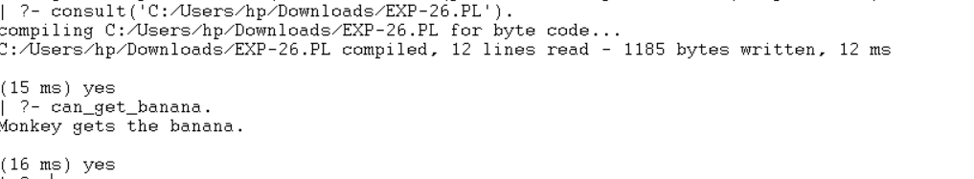

RESULTS:
Thus, the Monkey Banana problem was successfully implemented using Prolog.

